PRODUCT MANAGEMENT WITH GENERATIVE & AGENTIC AI
Final Submission Document
FoodIntel AI
AI Sales Intelligence Copilot for Food-Industry Sales Teams
Field | Submission Detail
Problem statement | Design an AI-powered agent to automatically curate and deliver timely, contextual company insights sourced from financial data, news and social media to sales representatives before meetings, so that they are better informed and reduce manual research time.
Product identity | An enterprise-style AI sales intelligence operating system for food-industry sales reps.
MVP | Streamlit app with category login, command center, prospect brief, opportunity radar, CRM timeline, follow-up studio, AI copilot and Evidence & Audit Intelligence Store.
Submission note | Real interview recordings, screenshots and team IDs must be attached or hyperlinked before final PDF upload.

Team List and Contribution
Team Member | Student Code / ID | Contribution
Submission owner | Add official student ID before PDF export | Product concept, app direction, backend data model, final documentation and demo narrative.
Team member 2 | Add official student ID if applicable | User research, interview evidence, channel-test evidence, screenshots and presentation support.
Team member 3 | Add official student ID if applicable | PRD review, testing, Jira board, final PDF checks and live presentation support.

Before LMS upload
Replace the team rows with the actual team list and student codes/IDs. The guideline explicitly asks for team list and contribution.

Executive Summary
Food-industry sales representatives often spend 30-60 minutes manually researching every prospect before meetings by switching across Google listings, menus, review platforms, LinkedIn, CRM notes and social media. Despite this effort, meetings still suffer from incomplete context and generic pitches. FoodIntel AI solves this problem by automatically generating trusted, category-specific meeting intelligence that helps sales reps prepare faster, pitch more effectively and reduce repetitive manual research.
FoodIntel AI solves a very practical sales problem: food-industry sales representatives often walk into meetings with incomplete context because company research is scattered across Google, review platforms, menus, social signals, news, CRM notes and internal memory. The app turns that scattered research into a short, category-specific meeting preparation workflow.
The current MVP supports sales reps who sell packaging, ingredients, bakery ingredients, beverages, hygiene supplies, kitchen equipment, POS/CRM software and logistics/cold-chain services. After login, the selected category stays fixed across the app, so a packaging rep sees packaging-specific meetings, pitch logic, competitors, product matches and follow-up actions.
Page | Purpose
Seller Setup | Login by sales category using username/password.
Command Center | Prioritize today's meetings and show time saved metrics.
Prospect Brief | Deep company intelligence, what changed, pain points, product fit, pitch and trust data.
Opportunity Radar | Cross-account opportunities and geographic opportunity patterns.
CRM Timeline | Relationship history, previous signals and what changed since last meeting.
Follow-up Studio | Follow-up email draft, CRM actions and next-step tasks.
AI Copilot | Question-answering for the active prospect and logged-in category.
AI Workflow | Agentic Sales Intelligence Workflow, 8-layer architecture and Evidence & Audit Intelligence Store.

Why Food Industry?
The food industry was selected because food-service sales teams operate in highly dynamic environments driven by customer reviews, delivery quality, menu shifts, geographic expansion and supplier competition. This creates a strong need for contextual, real-time account intelligence before meetings, making the industry highly suitable for AI-powered sales preparation workflows.

Visual System Flow
Step | System action | Salesperson value
1. Meeting Detected | Upcoming meeting appears in Command Center. | Rep knows which account to prepare first.
2. Signal Collection | Financial proxy, news, social, review and competitor signals are collected. | Research is gathered without manual searching.
3. AI Insight Ranking | Decision Intelligence Engine ranks what matters most. | Rep sees useful signals instead of raw noise.
4. Prospect Brief | Brief shows what changed, pain points, product fit and trust data. | Rep gets meeting-ready context.
5. Sales Strategy | Pitch, questions, objections and competitor positioning are generated. | Rep can sell with a sharper narrative.
6. CRM + Follow-up | Follow-up email, CRM note and next-step actions are produced. | Meeting output becomes action immediately.

Visual Architecture Diagram
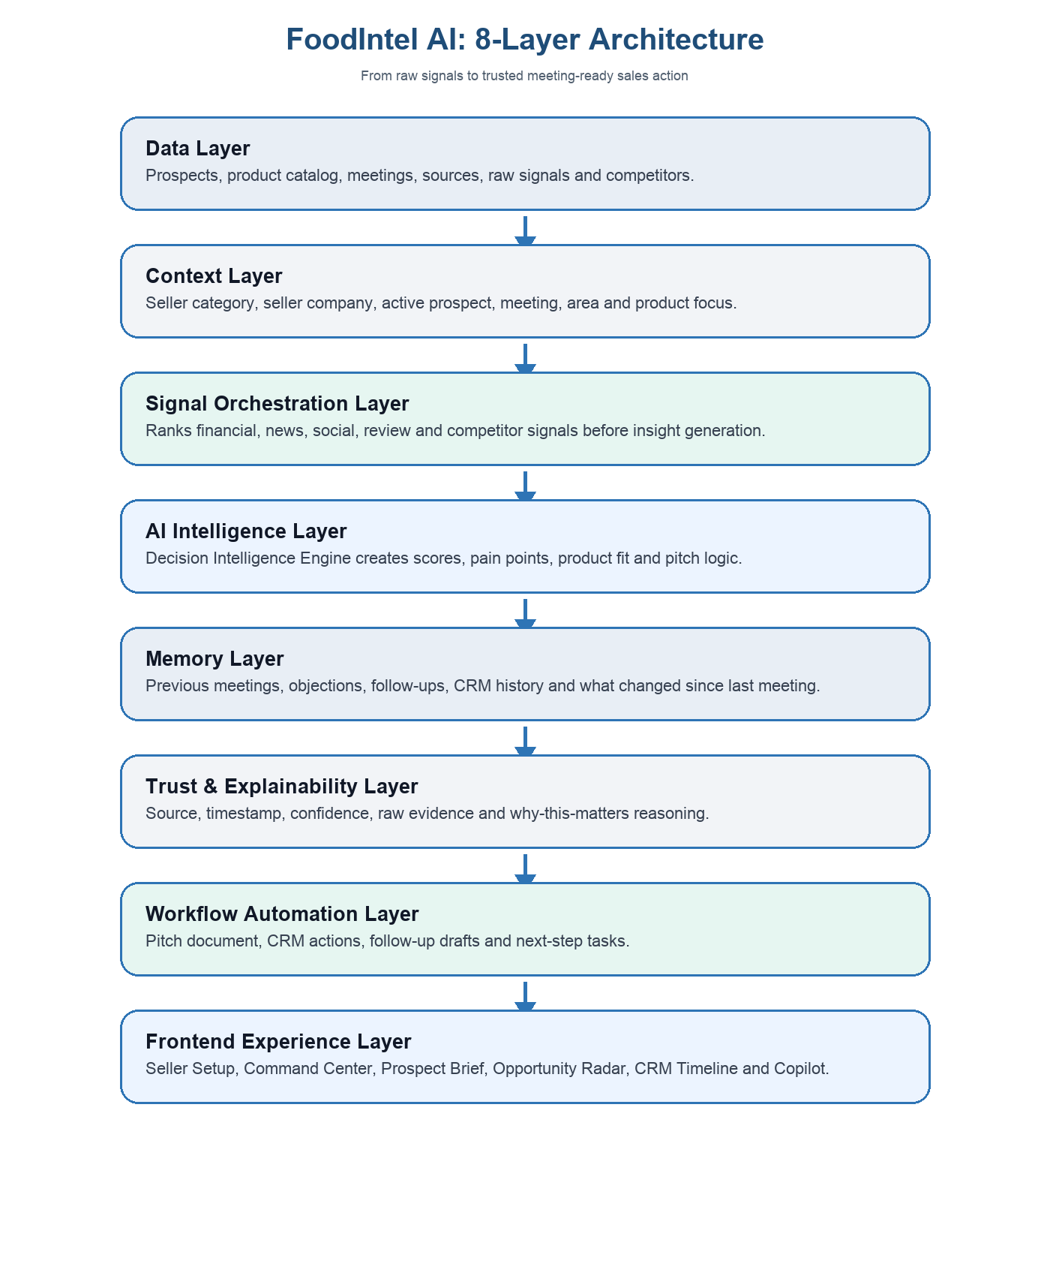
Diagram note: the architecture moves from data and context into signal orchestration, the Decision Intelligence Engine, memory, explainability, workflow automation and finally the salesperson-facing experience.

Before vs After Workflow
Manual workflow | FoodIntel AI workflow
Search Google manually. | AI-curated prospect brief.
Check reviews separately. | Unified signals from review, social and category-fit logic.
Read CRM notes manually. | Memory layer and what changed since last meeting.
Prepare pitch manually. | AI-generated category-specific pitch.
Write follow-up manually. | Automated follow-up and CRM actions.

MVP vs Production Clarity
Data reality
The current MVP uses structured proxy datasets and simulated intelligence workflows to validate product logic, workflow continuity and contextual AI behavior. A production implementation would integrate live financial APIs, news feeds, CRM systems, social listening tools and restaurant-review platforms.

What Makes This Different?
Generic AI tools | FoodIntel AI
Generic summaries. | Category-specific intelligence for what the rep actually sells.
No workflow continuity. | Persistent active context across all pages.
No explainability. | Trust layer with source, timestamp, confidence and reasoning.
No workflow automation. | Follow-up Studio and CRM actions.
Generic chatbots. | Meeting-prep operating system for food-industry sales teams.

Business Impact
KPI | Current MVP estimate
Manual research reduction | 82%
Average prep time reduction | 4.5 hours/day
Brief generation speed | Under 5 minutes
Follow-up automation | One-click draft and CRM action generation
Context continuity | Persistent across the full workflow

These values are MVP estimates based on comparing the current manual research workflow with the AI-assisted preparation workflow in the prototype. They should be validated through live pilot usage before production claims.

Why Explainability Matters
Because sales decisions directly affect customer relationships and revenue outcomes, FoodIntel AI prioritizes explainability and verification instead of opaque AI-generated recommendations. Every critical insight includes source references, timestamps, confidence indicators and reasoning summaries to help reps and managers validate AI output before acting on it.

Context Continuity
One of the strongest product decisions is the global active context. After a sales rep logs into a category and selects a prospect, the app keeps the same seller, category, active prospect, meeting and product focus across Command Center, Prospect Brief, Opportunity Radar, CRM Timeline, Follow-up Studio, AI Copilot and the Agentic Sales Intelligence Workflow page. This prevents the common student-app problem where different pages show different accounts or unrelated recommendations.

Future Roadmap
Roadmap phase | Future capability
Phase 1 | Live financial and news APIs.
Phase 2 | CRM integrations and account-owner sync.
Phase 3 | Team analytics dashboard for sales managers.
Phase 4 | Predictive deal scoring and opportunity forecasting.
Phase 5 | Voice meeting assistant and automatic CRM note capture.

8-Layer Product Architecture
Layer | What it does in this app
Data Layer | Stores prospects, restaurant data, product catalog, meeting records, source records, raw signals, competitors and impact metrics.
Context Layer | Locks seller category, seller company, active prospect, active meeting, active area and product focus.
Signal Orchestration Layer | Collects and ranks financial, news, social, review and competitor signals before AI generates insights.
AI Intelligence Layer | Creates lead score, opportunity score, pain points, product matches, sales pitch and discovery questions.
Memory Layer | Stores previous meetings, objections, follow-ups, CRM history, brief versions and what changed since last meeting.
Trust & Explainability Layer | Shows source, timestamp, confidence score, raw evidence and why each insight matters.
Workflow Automation Layer | Creates pitch downloads, CRM tasks, follow-up drafts, reminders and impact metrics.
Frontend Experience Layer | Presents the rep-facing workflow through Streamlit pages.

Phase 1: Problem Exploration and Business Thinking
1. Begin exploring product ideas to solve the selected problem.
The selected problem is sales meeting preparation. A rep needs timely and contextual account insight before meeting a restaurant, cloud kitchen, cafe, hotel, QSR outlet or food-service chain. Today this work is slow because the rep has to manually search Google listings, menus, reviews, news, social activity, CRM notes and supplier context.
The product idea is FoodIntel AI: an AI sales intelligence copilot that prepares a rep before the meeting, explains why each insight matters, and turns the research into a pitch, questions, objections, CRM actions and follow-up.
2. ERRC framework.
ERRC | FoodIntel AI decision
Eliminate | Generic dashboards, repeated manual research and unsupported AI claims.
Reduce | Preparation time, context mismatch between pages, irrelevant product suggestions and hallucination risk.
Raise | Source visibility, category relevance, meeting confidence and salesperson productivity.
Create | Category login, active prospect context, what changed since last meeting, AI pitch, trust layer and Evidence & Audit Intelligence Store.

3. SCAMPER framework.
SCAMPER | Application
Substitute | Replace manual search with AI-curated pre-meeting brief.
Combine | Combine prospect data, menu cues, reviews, competitor signals, category catalog and CRM memory.
Adapt | Adapt enterprise account-intelligence workflows to Indian food-industry field sales.
Modify | Make the app category-specific so each rep sees only the product logic they sell.
Put to another use | Use public restaurant data for supplier fit, pitch strategy and route prioritization.
Eliminate | Remove repeated data and disconnected pages.
Reverse | Start from the upcoming meeting, then trigger research agents automatically.

4. What are the sources for these ideas and how will ideas be gathered?
- The official capstone problem statement around AI-curated financial, news and social insights.
- Manual sales-prep workflows of reps selling packaging, ingredients, beverages, equipment, POS/CRM and logistics.
- Public restaurant data, menus, reviews, delivery cues and area-level food-service density.
- User interviews with sales reps, sales managers, food business owners and operations users.
- Prototype observation: confusion reduced when the app has one active category and one active prospect across all pages.
5. Who are the customers?
- Primary customer: food-industry sales reps who sell B2B products/services to restaurants, cafes, QSRs, hotels, cloud kitchens and bakeries.
- Economic buyer: sales head, regional manager, distributor owner or B2B supplier founder.
- Daily users: field sales reps and business development executives.
- Influencers: procurement managers, chefs, operations heads and restaurant owners who receive better prepared sales conversations.
6. Who is the competition?
- Manual research using Google, Zomato/Swiggy listings, social media, LinkedIn and CRM notes.
- Generic CRM tools that store contacts but do not produce food-industry meeting intelligence.
- Generic AI chatbots that summarize but do not know seller category, product catalog, competitors or active prospect context.
- Sales managers or analysts who prepare account notes manually.
7. What is the customer value proposition?
CVP
FoodIntel AI helps food-industry sales reps walk into meetings better prepared by converting scattered public and CRM signals into a category-specific meeting brief, pitch, questions, competitor context and follow-up actions in minutes instead of hours.

8. Value proposition canvas.
Customer jobs / pains / gains | FoodIntel AI response
Job: prepare before a meeting | Command Center and Prospect Brief create the pre-meeting workflow.
Pain: too much manual research | Research time saved metric and automated brief generation.
Pain: generic AI output | Category Login and Product Catalog Memory make outputs specific to what the rep sells.
Pain: cannot trust AI | Source, timestamp, confidence score, raw signal and why-this-matters labels.
Gain: better meeting conversion | Pitch, product fit, objections, discovery questions and follow-up studio.

9. Why will customers switch to your solution?
- It reduces manual research by an estimated 82%.
- It makes the rep's pitch specific to the logged-in sales category.
- It keeps every page connected to the same active prospect, avoiding confusing data mismatch.
- It shows trust data, so sales managers can review what the AI used before reps rely on it.
- It completes the workflow from meeting detection to brief, strategy, CRM action and follow-up.
10. Unit of sale, revenue model, demand forecasting, cost structure and key metrics.
Business item | Answer
Unit of sale | Per sales rep seat per month, with team/admin packages for sales managers.
Revenue model | SaaS subscription, premium data/API add-ons, enterprise setup fee and usage-based AI credits.
Demand forecast | Estimate number of food-industry B2B sales teams x reps per team x monthly willingness to pay; validate through pilots.
Cost structure | App hosting, data/API costs, LLM usage, implementation, support, sales/onboarding and compliance review.
Key metrics | Research time saved, briefs generated, meeting prep completion, follow-ups generated, conversion uplift, active reps and renewal rate.

11. Phase 1 experimental task: 10 raw problem signals.
Signal source | What to capture | Project-specific search/question
Google Reviews | Complaints around leakage, delay, hygiene, inconsistent quality. | Search restaurants/cafes and capture review evidence.
Zomato/Swiggy reviews | Packaging, portion, delivery and taste complaints. | Collect examples that show supplier-related pain.
LinkedIn comments | Sales productivity, CRM, meeting-prep and AI sales-tool discussions. | Find comments from sales reps/managers.
Reddit/Twitter/X | Complaints about delivery packaging, food quality and service delay. | Capture public threads with screenshots.
App reviews: LinkedIn | Pain around finding buyer/contact information. | Relate to contact research before meetings.
App reviews: WhatsApp Business | Follow-up, customer communication and CRM note pain. | Relate to Follow-up Studio.
App reviews: Swiggy/Zomato | Customer-experience signals that sellers can solve. | Map to packaging/ingredient/hygiene opportunities.
Instagram comments | Customer sentiment on food outlets and new launches. | Map social signal to meeting intelligence.
Customer support complaint | Repeated confusion, escalation or unresolved issue. | Use as support journey evidence.
Field sales observation | Rep spends time manually searching and asking around. | Compare with AI-generated brief time.

Refined pain point for one mobile app: food-industry sales reps waste time switching between review platforms, social media and messaging apps to understand a prospect. They need one trusted meeting brief that tells them what changed, what to pitch and what evidence to verify.

Phase 2: Design Thinking, MVP and AI Integration
1. Outline the design thinking process.
- Empathize: interview reps, managers and food business owners about how they prepare for meetings.
- Define: reps need fast, trusted, category-specific context before meetings.
- Ideate: explore category login, active prospect context, trust labels, pitch generation and follow-up automation.
- Prototype: build a Streamlit MVP with Seller Setup, Command Center, Prospect Brief, Opportunity Radar, CRM Timeline, Follow-up Studio, AI Copilot and Agentic Sales Intelligence Workflow.
- Test: validate category consistency, relevance of pitch, trust labels, download workflow and time saved.
2. User personas.
Persona | Need | Pain | Success measure
Field Sales Rep | Prepare quickly before visits. | Manual research takes too long. | Brief ready in under 5 minutes.
Sales Manager | Ensure reps use consistent prep quality. | Hard to monitor research quality. | More prepared meetings and follow-ups.
B2B Supplier Founder | Improve conversion with small team. | Reps pitch generic products. | Higher trial-order rate.
Restaurant Owner | Receive relevant supplier conversations. | Generic vendor calls waste time. | Rep understands actual business needs.

3. User stories.
- As a packaging sales rep, I want the app to show packaging-specific opportunities so that I do not pitch irrelevant ingredients.
- As a sales manager, I want source and confidence labels so that I can trust the AI-generated brief.
- As a field rep, I want a downloadable Word pitch so that I can carry or share a meeting-ready summary.
- As a rep after a meeting, I want follow-up and CRM actions so that I do not lose next steps.
- As an evaluator/admin, I want to see the Agentic Sales Intelligence Workflow and Evidence & Audit Intelligence Store so that the agentic architecture is clear.
4. Will design and development be internal or outsourced? Why?
The MVP should be built internally because the product depends heavily on domain logic: seller categories, product catalog, prospect context, source trust, privacy boundaries and sales workflow. Outsourcing can be used later for UI polish, production integrations and security review, but the core intelligence and workflow should remain internal during discovery.
5. What are the tech capabilities and MVP features?
Capability | Current MVP implementation
Frontend | Streamlit multipage app.
Data | JSON restaurant/prospect dataset and generated enterprise backend store.
Context | Global active context for seller category, prospect, meeting, area and product focus.
AI logic | Local intelligence modules for brief, pitch, product match, score, signals and follow-up.
Documents | Word pitch download from Prospect Brief.
Future APIs | Financial APIs, news APIs, LinkedIn, Instagram, Google Reviews and CRM systems.

MVP Feature | Priority reason
Seller Setup | Prevents generic AI and locks category context.
Command Center | Gives the rep the next meetings to prioritize.
Prospect Brief | Core product value: meeting-ready intelligence.
What changed since last meeting | Wow feature and memory proof.
Explainability layer | Trust and academic AI maturity.
Follow-up Studio | Completes before/during/after workflow.
Agentic Sales Intelligence Workflow | Shows agentic architecture and Evidence & Audit Intelligence Store.

6. How would you prioritize features?
Prioritization uses RICE: reach, impact, confidence and effort. Highest priority goes to features directly tied to the problem statement: meeting detection, contextual research, trust labels, meeting brief and follow-up. Nice-to-have analytics are kept secondary unless they support meeting preparation.
7. How would you test product and features before deployment?
- Usability test: ask reps to prepare for the same prospect manually and with FoodIntel AI.
- Relevance test: check whether the pitch matches logged-in category.
- Trust test: ask users if source/timestamp/confidence labels increase confidence.
- Workflow test: open meeting from Command Center and confirm all pages keep the same prospect.
- Download test: verify the Word pitch document generates correctly.
- Backend test: validate meetings, raw signals, audit logs, product matches and brief versions exist.
8. How will you integrate AI/GenAI and Agentic AI?
Agent / AI component | Role
Calendar Agent | Detects upcoming meeting context.
Company Detection Agent | Maps restaurant name, area and segment.
Research Agent | Collects public listing/menu/source information.
Financial Data Agent | Estimates order potential using proxy data in MVP.
News Agent | Finds expansion and market movement signals.
Social Listening Agent | Detects review/social/customer-experience signals.
Review Analysis Agent | Finds complaints and strengths.
Insight Ranking Agent | Ranks what matters for the meeting.
Sales Strategy Agent | Creates pitch, questions and objections.
Follow-up Agent | Creates CRM actions and follow-up draft.

9. Phase 2 experimental task: JTBD interview questions for this project.
- Tell me about the last time you prepared for a restaurant, supplier or customer meeting.
- What information did you need before that meeting?
- Where did you search for that information?
- What took the most time?
- What information was difficult to trust or verify?
- What information would be useful but sensitive or private?
- What do you usually prepare before entering the meeting?
- What happens if you miss important context?
- If an AI assistant prepared a meeting brief, what should it include?
- What would make you not trust the AI output?
- Would source links, timestamps and confidence scores make the brief more credible?
- What should happen after the brief is generated?
- How should the app behave differently for a beginner rep and a senior sales manager?
- What would make you use this product repeatedly?
- What would make you stop using it after three months?
Interview type | Who to interview | Evidence needed
1 | Food-industry field sales rep | Recording link, raw notes, exact quote and feature insight.
2 | Sales manager / business development lead | Recording link, raw notes, exact quote and feature insight.
3 | Restaurant/cafe/cloud kitchen owner or manager | Recording link, raw notes, exact quote and feature insight.
4 | Supplier/distributor owner | Recording link, raw notes, exact quote and feature insight.
5 | CRM/data/operations person | Recording link, raw notes, exact quote and feature insight.

Phase 3: Project Plan, Methodology, Ethics and Lean Canvas
1. Create a sample project plan.
Sprint | Focus | Deliverables
Sprint 1 | Problem and data foundation | Problem statement, personas, raw signal plan, product catalog and prospect data.
Sprint 2 | Core workflow | Seller Setup, Command Center, active context and Prospect Brief.
Sprint 3 | Decision Intelligence Engine | Signal orchestration, product match, what changed, trust labels and pitch download.
Sprint 4 | Workflow completion | Opportunity Radar, CRM Timeline, Follow-up Studio, AI Copilot and Agentic Sales Intelligence Workflow.
Sprint 5 | Testing and submission | Bug fixes, demo recording, PRD, evidence links and final PDF.

2. What methodology will you use? Why?
The recommended methodology is Agile with Lean Startup experimentation. Agile fits because the product depends on quick feedback from reps and evaluators. Lean Startup fits because the riskiest assumptions are not technical; they are whether reps trust AI-prepared briefs, whether category-specific logic improves usefulness and whether managers see enough time savings to pay.
3. Create a Jira board and attach screenshot.
Column | Example tasks
Backlog | Live API integrations, admin analytics, advanced CRM sync.
To Do | Add real interview links, add screenshots, export final PDF.
In Progress | UI polish, final PRD and demo story.
Review | Test login, pitch download, source trust labels and context consistency.
Done | Seller Setup, Command Center, Prospect Brief, Evidence & Audit Intelligence Store.

Attach Jira screenshot in the final PDF. The screenshot should show board name, columns and representative tasks.
4. Ethical considerations.
- Do not claim private customer data unless it is permissioned or owned by the company.
- Clearly label MVP proxy signals versus real API-connected signals.
- Show source, timestamp, confidence and why-this-matters for each insight.
- Allow reps to verify supplier, volume, decision maker and pain points during the visit.
- Avoid unfair competitor claims; use competitor information as a verification prompt, not as confirmed fact.
- Protect customer and CRM data through access control and category/role-based context.
5. Lean Model Canvas.
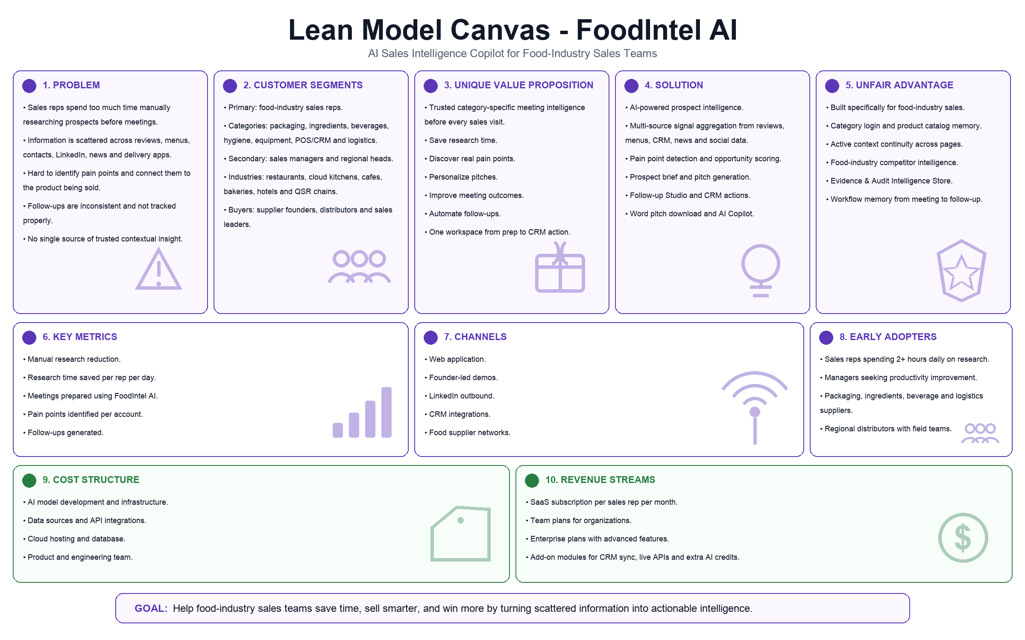
Canvas note: this follows the default Lean Model Canvas structure while tailoring each block to FoodIntel AI's food-industry sales-preparation use case.

Phase 4A: Marketing, Channels and Launch
1. Outline STP for the new product.
STP | Answer
Segmentation | Food-industry B2B sellers by category: packaging, ingredients, beverages, hygiene, equipment, POS/CRM and logistics.
Targeting | Small-to-mid B2B supplier teams and regional sales teams in Hyderabad/India food-service markets.
Positioning | The meeting-prep operating system for food-industry sales teams, not a generic AI dashboard.

2. Brand and 7Ms.
Item | Answer
Brand | FoodIntel AI
Mission | Help sales reps prepare better before every food-industry meeting.
Market | B2B food-service supplier and sales teams.
Message | Spend less time researching; enter every meeting with a trusted, category-specific brief.
Media | LinkedIn, demo videos, founder-led webinars, supplier communities and industry events.
Money | Pilot discounts, per-seat SaaS plans and enterprise setup fees.
Measurement | Briefs generated, time saved, demo conversion, trial-to-paid conversion and renewal.
Moment | Before daily sales visits and key account meetings.
Mechanism | Agentic research pipeline, active context, trust layer and follow-up automation.

3. Launch strategy.
- Start with a focused Hyderabad food-supplier pilot.
- Use category-specific demo accounts: packaging, ingredients, beverages, hygiene, equipment, POS/CRM and logistics.
- Offer a two-week pilot where reps compare manual research time with AI-generated prep time.
- Publish short LinkedIn demo clips showing the before-meeting workflow.
- Use case-led outreach: packaging leakage, ingredient consistency, beverage menu expansion, hygiene compliance and logistics SLA.
4. Channel strategy and omnichannel choice.
The launch should be omnichannel but not broad. Online channels create scale and proof; offline demos create trust in a B2B sales audience. Owned channels should lead early because the product needs explanation and trust. Partner channels can scale after pilots with suppliers or distributor networks.
Channel | Role | Risk
LinkedIn outbound | Reach sales managers and founders. | Can feel generic without strong demo proof.
Founder-led demo call | Best trust-building channel. | Scales slowly.
Supplier/distributor referrals | High relevance and warm trust. | Depends on partner willingness.
Industry WhatsApp/community groups | Fast reach to field sellers. | Can leak trust if message looks spammy.
Food-service events | High-quality conversations. | Higher cost and slower cadence.

5. User flow and user journey.
- Rep logs in through Seller Setup using category credentials.
- Command Center shows today's meetings and time saved.
- Rep opens a prospect brief.
- AI shows what changed, pain points, product fit, pitch, questions, competitors and trust data.
- Rep downloads the Word pitch or asks AI Copilot a question.
- After the meeting, Follow-up Studio creates email draft and CRM actions.
- Manager reviews impact metrics and audit evidence in the Agentic Sales Intelligence Workflow.
6. Phase 4A experimental task 1: two real channel actions.
Channel action | What to do | What to document
LinkedIn outreach test | Send a short product message or demo request to a sales manager/founder. | Screenshot, time taken, reply/drop-off, friction and trust issue.
Demo/onboarding attempt | Ask a potential user to open the app/login/demo flow or watch recording. | Screenshot/recording, time taken, confusion points and drop-off.

60-second launch explanation: FoodIntel AI helps food-industry sales reps prepare before meetings by automatically building a trusted, category-specific brief from prospect data, public signals, product catalog, competitors and CRM memory. Instead of searching manually for an hour, the rep sees what changed, what to pitch, what to ask and what follow-up to send.
7. Phase 4A experimental task 2: renewal-objection interview questions.
- If you used FoodIntel AI for three months, what would make you not renew?
- Would price, low usage, trust, complexity or unclear value be the main reason?
- What result would make renewal feel obvious?
- Which feature would you stop using first?
- What would make your manager approve renewal?
- Would better onboarding, training or templates increase usage?
- Would you prefer monthly pricing, annual pricing or per-meeting credits?
Objection theme | Retention lever
Trust issues | Source links, confidence scores, raw signal view and field-verification checklist.
Low perceived value | Research time saved dashboard and before/after prep comparison.
Usage fatigue | Daily meeting reminders and one-click brief generation.
Price discomfort | Pilot pricing and team bundles.
Complexity | Cleaner onboarding, default category setup and simpler page ownership.

Phase 4B: Service Strategy, CLV, Renewal and Support
1. Customer service strategy.
- In-app help for login, category setup, source interpretation and pitch download.
- Support playbooks for data mismatch, wrong category, missing prospect and trust-label questions.
- Onboarding checklist for sales managers.
- Monthly review with customer team to compare time saved and usage.
2. Steps to increase CLV and renewal.
- Show measurable time saved and briefs generated.
- Add customer-specific product catalog and CRM integrations.
- Create habit loops around daily meeting prep.
- Give sales managers team-level visibility.
- Offer more categories and API integrations in higher plans.
3. Growth hacks/loops.
- Rep shares professional pitch document with prospect, increasing product visibility.
- Manager invites more reps after seeing prep-time savings.
- Category-specific templates create repeat usage.
- Follow-up emails include consistent value proof, improving conversion stories.
4. Phase 4B experimental task: business-owner support interview questions.
- What are the most common customer support issues in your business?
- How does a customer usually raise a complaint?
- Where do customers get confused, irritated or drop off?
- What is your best-case and worst-case resolution time?
- When do customers follow up repeatedly?
- When do customers escalate?
- When do customers stop responding?
- What exact words do customers use in complaints?
- What process improvement would reduce repeat issues?
- What product/UX improvement would prevent confusion?
- What communication improvement would calm customers faster?
Support evidence required | How it connects to FoodIntel AI
3 business-owner interviews | Shows how B2B customers experience support and renewal pain.
5 real customer support queries | Can inform Follow-up Studio and objection handling language.
Resolution time | Supports service strategy and CLV thinking.
Frustration moments | Improves onboarding and support copy.

Phase 5: Build, Demo and PRD
1. Build wireframes for your product.
The MVP wireframe structure is represented in the Streamlit app itself: Seller Setup, Command Center, Prospect Brief, Opportunity Radar, CRM Timeline, Follow-up Studio, AI Copilot and Agentic Sales Intelligence Workflow. Screenshots from each page should be inserted into the final PDF or attached as evidence.
2. Build and demo an MVP.
MVP area | What the demo should show
Seller Setup | Login as a sales category and show category locked in sidebar/context bar.
Command Center | Show today's meetings, priority and research time saved.
Prospect Brief | Show what changed, product fit, pitch, competitor intelligence and trust data.
Word download | Download the category-specific pitch document.
AI Copilot | Ask what to sell or who the competitors are.
Follow-up Studio | Generate email and CRM actions.
Agentic Sales Intelligence Workflow | Show agent pipeline, 8-layer architecture and Evidence & Audit Intelligence Store.

3. Full PRD.
PRD section | Answer
Product name | FoodIntel AI.
Problem | Sales reps lose time and quality while manually researching prospects before meetings.
Target user | Food-industry B2B sales reps and sales managers.
Goal | Reduce manual research time and improve meeting readiness.
Core workflow | Login -> meetings -> prospect brief -> pitch/questions -> copilot -> follow-up/CRM.
Must-have requirements | Category login, active context, prospect brief, trust data, product match, what changed, follow-up actions.
AI requirements | Signal orchestration, insight ranking, explainability, confidence scores, source registry and audit log.
Non-goals | Not a restaurant operations dashboard, not a generic CRM clone, not a private-data scraper.
Success metrics | 82% manual research reduction, 4.5 hours saved today, 12 briefs generated, conversion uplift and renewal.
Risks | Data accuracy, hallucination, privacy, stale public data and over-trust in proxy signals.
Mitigation | Source labels, timestamps, confidence, field verification prompts and production API integrations.

4. Demo script.
- Open with the problem: reps waste time researching and still miss context.
- Say the core demo line: Instead of spending an hour researching manually, the rep receives a trusted, meeting-ready intelligence brief in minutes.
- Login as a category, for example Packaging.
- Show the global context bar: seller, category, active prospect, meeting and product focus.
- Open Command Center and explain time saved.
- Open Prospect Brief and show what changed since last meeting.
- Show trust data: source, timestamp, confidence and why it matters.
- Show product match and downloadable Word pitch.
- Ask AI Copilot one question: Who are the likely competitor suppliers?
- Generate follow-up and CRM actions.
- End with the Agentic Sales Intelligence Workflow: 8 layers, agents and Evidence & Audit Intelligence Store.

Final Submission Checklist
- Add team names and official student codes/IDs.
- Hyperlink real interview recordings, MVP recording and required screenshots.
- Attach 10 raw problem signal screenshots and links.
- Attach Jira board screenshot.
- Attach channel test screenshots and renewal/support interview evidence.
- Export the final Word document to PDF before LMS upload.
- Search final PDF for unfinished placeholders before submission.

